**CS595 - Assignment 13**

* Create a database and give it your IIT id. To do this just enter the following at the mongodb shell: use <IIT ID>. This will set the shell variable ‘db’ to this new database.
* Load the collection unicorns with data by executing the script ex2.js which is located in the jrosen subdirectory as follows:

load(“/home/mdb1/jrosen/ex3.js”)

* Confirm this has all worked by executing the following command

db.unicorns.find();

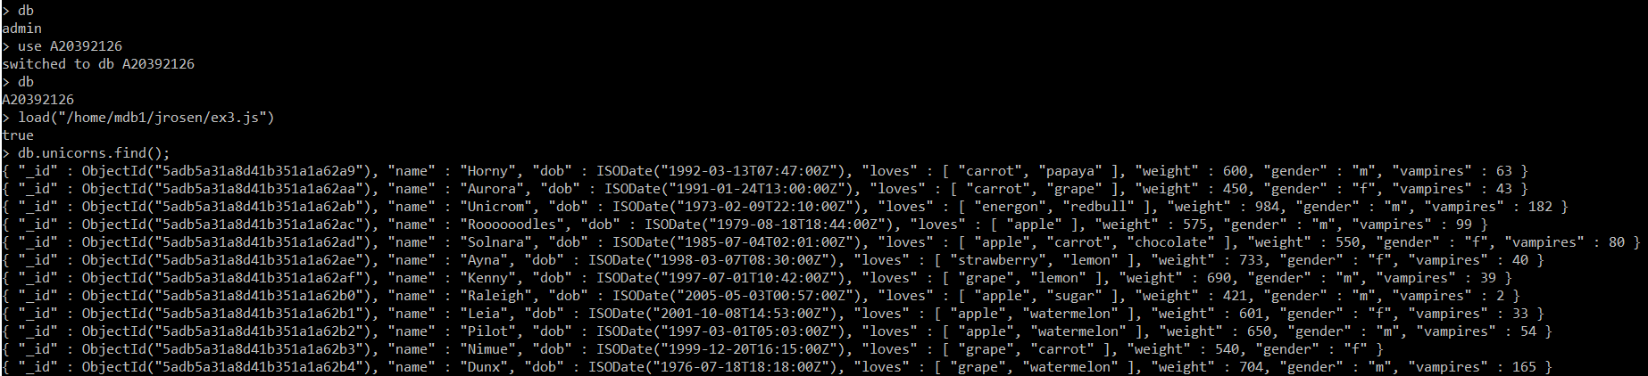

1. Write a command that finds all unicorns having weight less than 500 pounds. Include the code you executed and some sample output as the result of this exercise.



**Command Executed:**

db.unicorns.find({ weight: { $lt: 500 }});

1. Write a command that finds all unicorns who love apples. Hint, search for “apple”. Include the code you executed and some sample output as the result of this exercise.

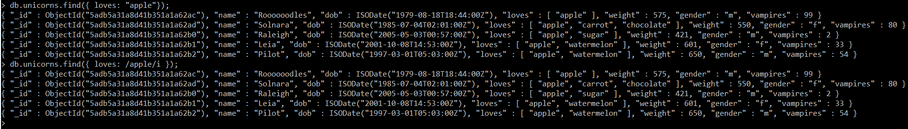

**Command Executed:**

db.unicorns.find({ loves: "apple"});

db.unicorns.find({ loves: /apple/i });

1. Write a command that adds a unicorn with the following attributes to the collection. Note dob means “Date of Birth.”

|  |  |
| --- | --- |
| Attribute | Value(s) |
| Name | Malini |
| dob | 11/03/2008 |
| Loves | Pears and grapes |
| Weight | 450 |
| Gender | F |
| Vampires | 23 |
| Horns | 1 |

Include the code you executed to insert this unicorn into the collection along with the output of a find command showing it is in the collection.

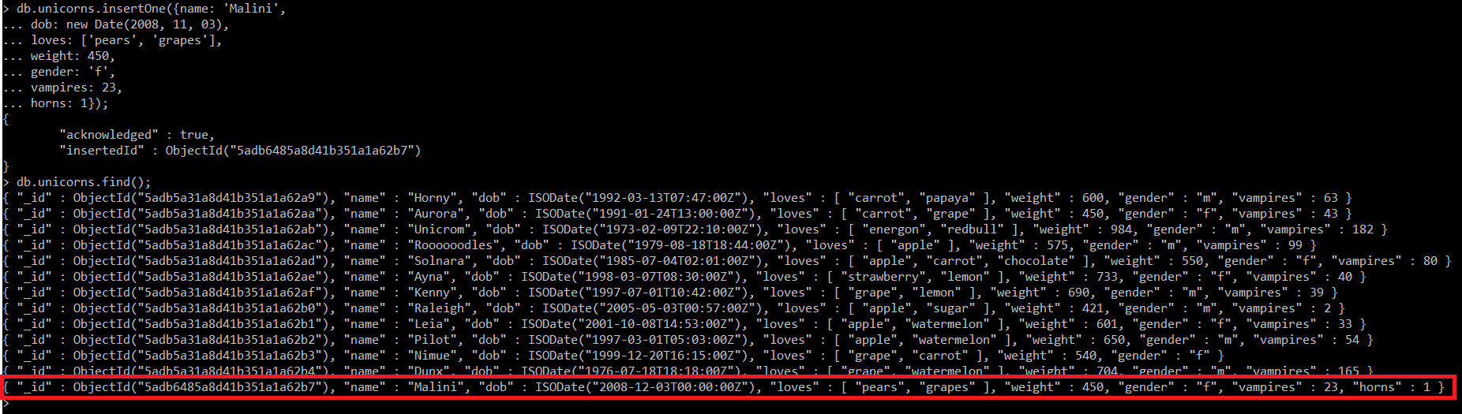

**Command Executed:**

db.unicorns.insertOne({name: 'Malini',

dob: new Date(2008, 11, 03),

loves: ['pears', 'grapes'],

weight: 450,

gender: 'f',

vampires: 23,

horns: 1});

db.unicorns.find();

1. Write a command that updates the above record to add apricots to the list of things Malini loves. Include the code you executed and some sample output showing the addition.



**Command Executed:**

db.unicorns.updateOne(

{ name: "Malini" },

{ $push: { loves: 'apricots' } }

);

db.unicorns.find({ name: "Malini" });

***Alternative approach (Static):***

db.unicorns.updateOne(

{ name: "Malini" },

{ $set: { loves: ['pears', 'grapes', 'apricots'] } }

);

db.unicorns.find({ name: "Malini" });

1. Write a command that deletes all unicorns with weight more than 600 pounds. Include the code you executed and some sample output as the result of this exercise.

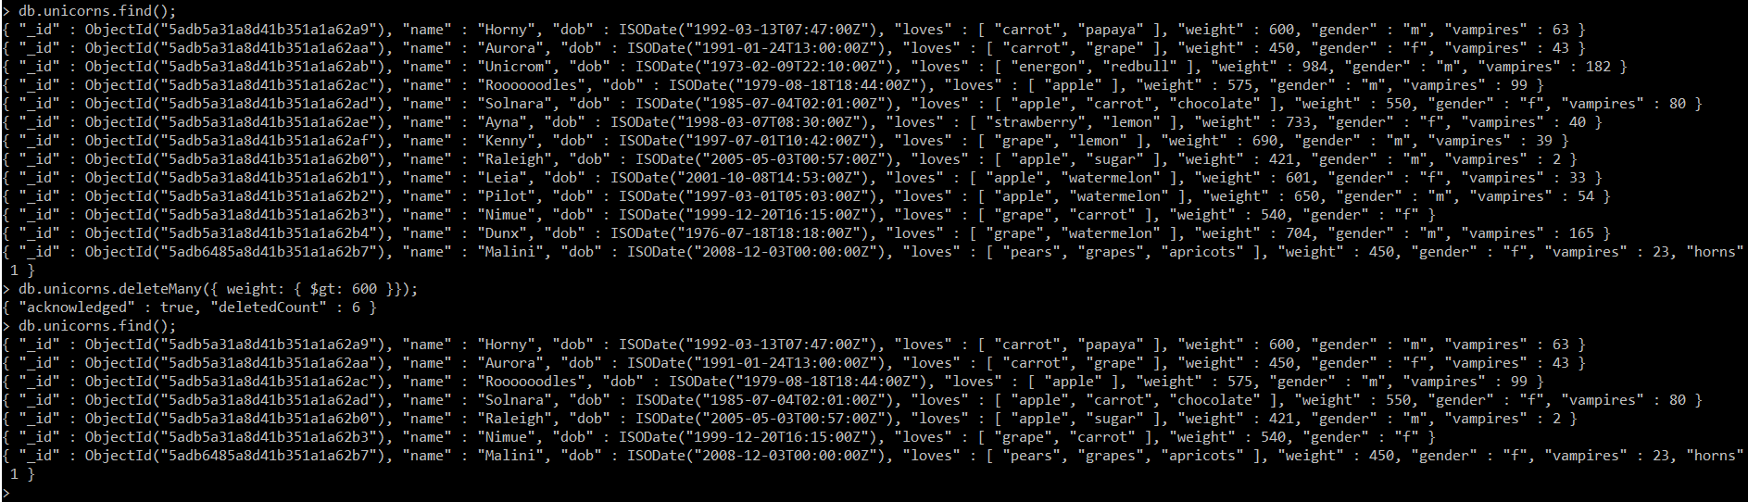

**Command Executed:**

db.unicorns.find();

db.unicorns.deleteMany({ weight: { $gt: 600 }});

db.unicorns.find();